**Project Title: Blood Donor Management System**

**Problem Statement**

Blood donation and availability are often managed manually through registers and phone calls.

• Lack of centralized system leads to delays in finding compatible donors during emergencies.

• Miscommunication between hospitals, blood banks, and donors results in shortages.

• Difficulty in maintaining donor history, eligibility, and tracking regular donors.

• Emergency blood requests are not communicated effectively to potential donors.

• No proper reporting system to analyze donation trends and shortages.

**Project Overview**

• A centralized, automated platform for managing donors, blood inventory, and requests.

• Real-time donor matching based on blood group and location.

• Hospitals and blood banks can raise urgent blood requests and notify eligible donors instantly.

• Dashboards and reports for monitoring donor activity, blood availability, and hospital demand.

• Secure storage of donor and patient data with privacy compliance.

**Objectives**

• Digitize donor registration, hospital requests, and blood availability tracking.

• Provide dashboards for hospitals, blood banks, and administrators to monitor real-time data.

• Allow donors to view their donation history, eligibility, and receive alerts.

• Generate real-time alerts for urgent requests and donor reminders.

• Ensure data accuracy, privacy, and security at all levels.

**Use Cases**

• Donor Registration & Management: Donors register, update health status, and check eligibility for

donation.

• Blood Inventory Management: Hospitals and blood banks update available blood units with expiry

tracking.

• Blood Request & Allocation: Hospitals raise requests; system matches with nearest eligible donors.

• Notifications & Alerts: Donors get alerts for urgent requests, upcoming eligibility, and reminders.

# Phase 1: Problem Understanding & Industry Analysis

## Requirement Gathering

* Collect requirements from hospitals, donors, patients, and blood banks.
* Identify key pain points: manual processes, delays in finding donors, miscommunication, lack of real-time updates.
* Document system requirements: donor registration, blood request, alerts, inventory tracking, and reporting.

## Stakeholder Analysis

* Donors: Register, update health status, track donation history, and receive alerts.
* Hospitals: Request blood urgently and manage inventory efficiently.
* Blood Banks: Update stock, manage expiry dates, and ensure timely donor-hospital matches.
* Healthcare Administrators: Monitor availability, donor activity, and compliance with standards.
* Patients: Benefit indirectly from faster donor matching and emergency response.

## Business Process Mapping

* Current Process: Manual donor identification via phone calls or registers.
* Challenges: Slow emergency response, no centralized donor history, limited reporting.
* Future Process: Centralized donor database, automated matching, dashboards for hospitals and admins, real-time donor notifications.

## Industry-Specific Use Case Analysis

* Donor Management: Digital registration, eligibility monitoring, health checks, and reminders.
* Emergency Response: Instant donor matching for hospital requests.
* Inventory Tracking: Blood unit expiry monitoring and shortage alerts.
* Compliance: Ensure privacy, security, and adherence to government guidelines for blood donation.

## AppExchange Exploration

* Explore existing healthcare and blood bank management apps for Salesforce.
* Identify reusable components such as donor/volunteer management, healthcare CRMs, and alert systems.
* Evaluate whether customization or integration of existing apps provides better efficiency.

# Phase 2: Org Setup & Configuration

1. Salesforce Editions

* Using Salesforce Developer Edition Org.
* Developer Edition provides Enterprise-level features free with limited licenses and storage.
* Suitable for student projects and practice

**2. Company Profile Setup**

* Organization Name: Blood Donor Management Org
* Default Locale: English (India)
* Default Language: English
* Default Time Zone: (GMT +05:30) India Standard Time (Asia/Kolkata)
* Default Currency: INR (Indian Rupee)

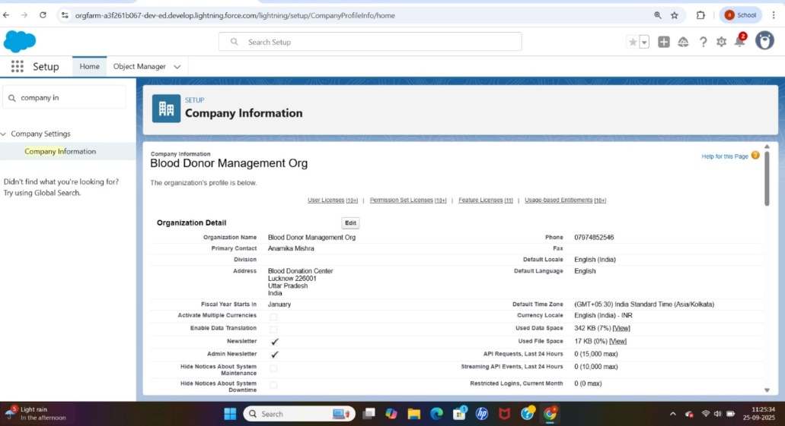

**3. Business Hours**

* Name: Blood Donation Hours
* Time Zone: GMT +05:30 India Standard Time
* Start: 9:00 AM
* End: 6:00 PM

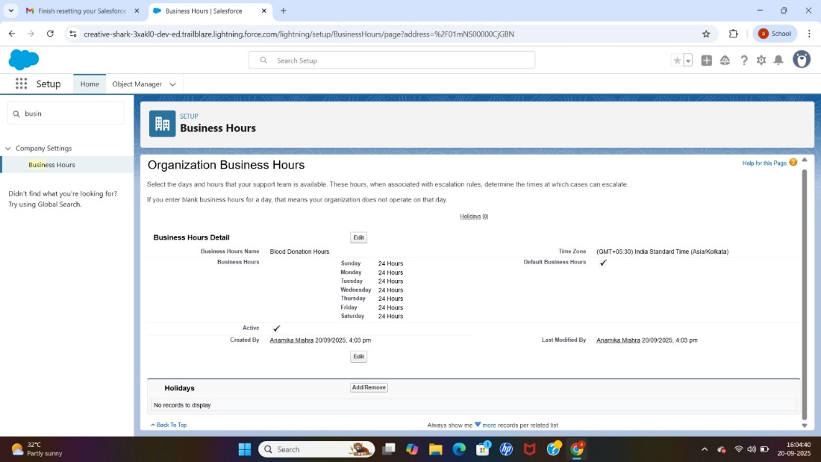

Holiday Name: World Blood Donor Day

Date: 6/14/2026 (All Day)

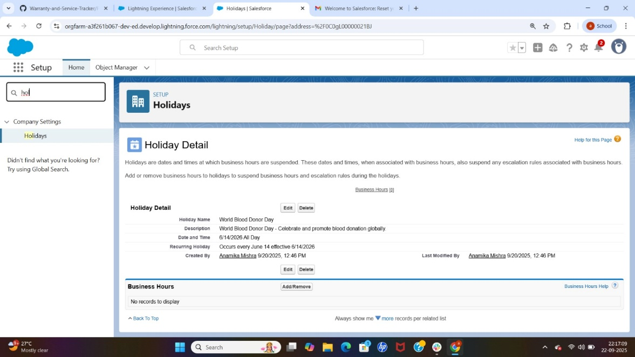

4. Fiscal Year Settings

* Fiscal Year: Standard (January-December).
* Custom Fiscal Year not enabled (not needed for this project).

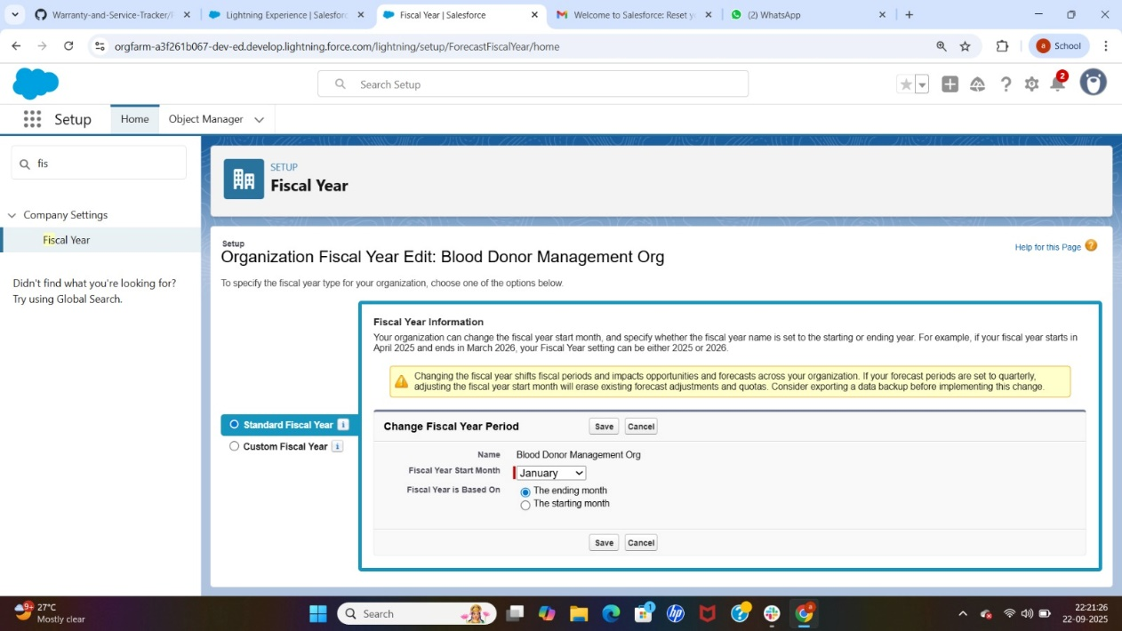

**5. User Setup & Licenses**

* Created 2 Test Users

User 1:

* First Name: Hospital
* Last Name: Manager
* Role: Hospital Manager
* User License: Salesforce
* Profile: Standard User

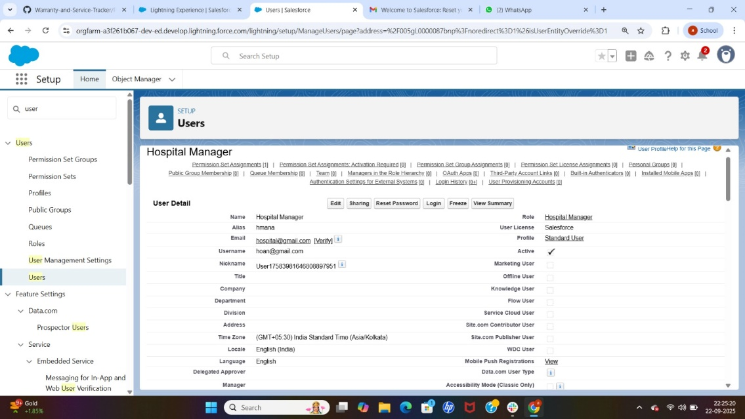

User 2:

* First Name: Blood
* Last Name: Donor
* Role: Donor
* User License: Salesforce
* Profile: Standard User

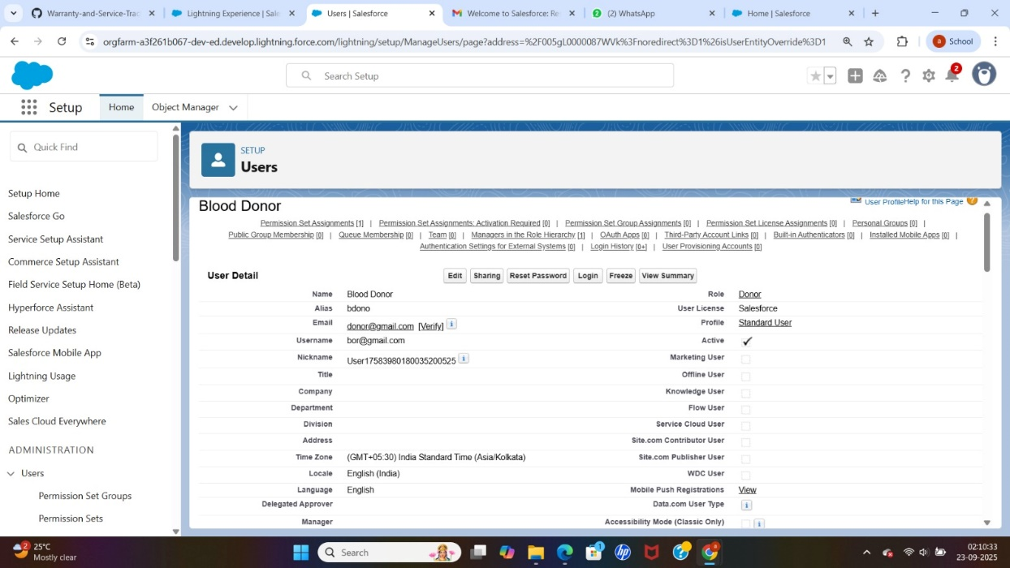

**6 Profiles**

1. Go to Setup → Profiles.

2. Clone a profile:

Name: Donor Profile

Permission: Donor__c → Read/Edit

3. Clone another profile:

Name: Hospital Profile

Permissions:

Donor__c → Read Only

Donation_Request__c → Read/Write

Donation_Event__c → Read/Write

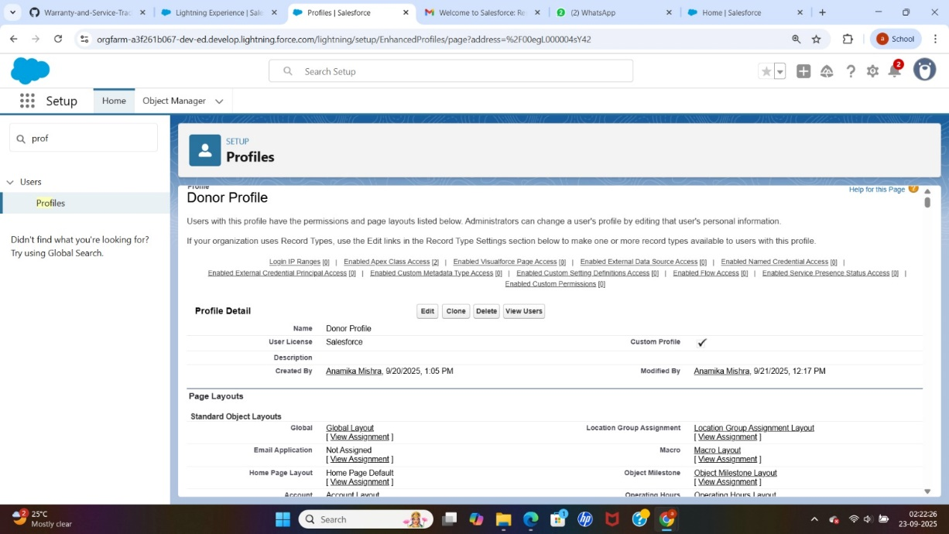

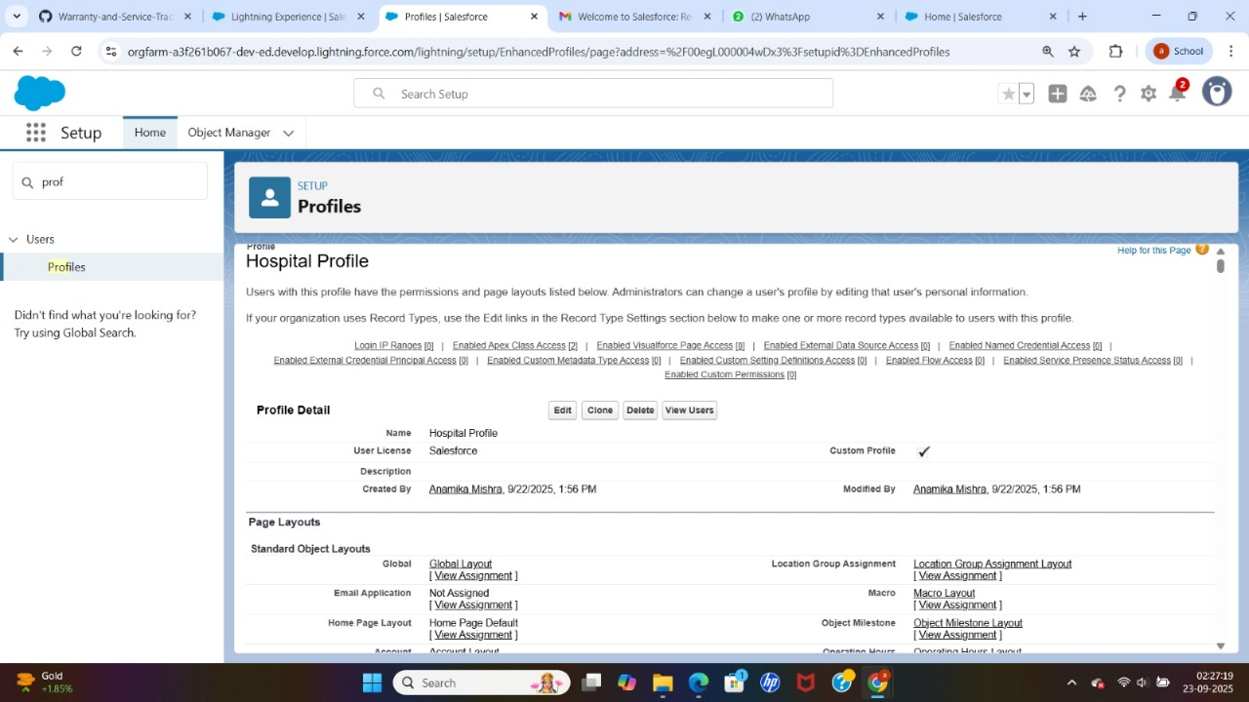

7.Roles

* Role hierarchy created
* Blood Donor Management Org (top)
* Hospital Manager

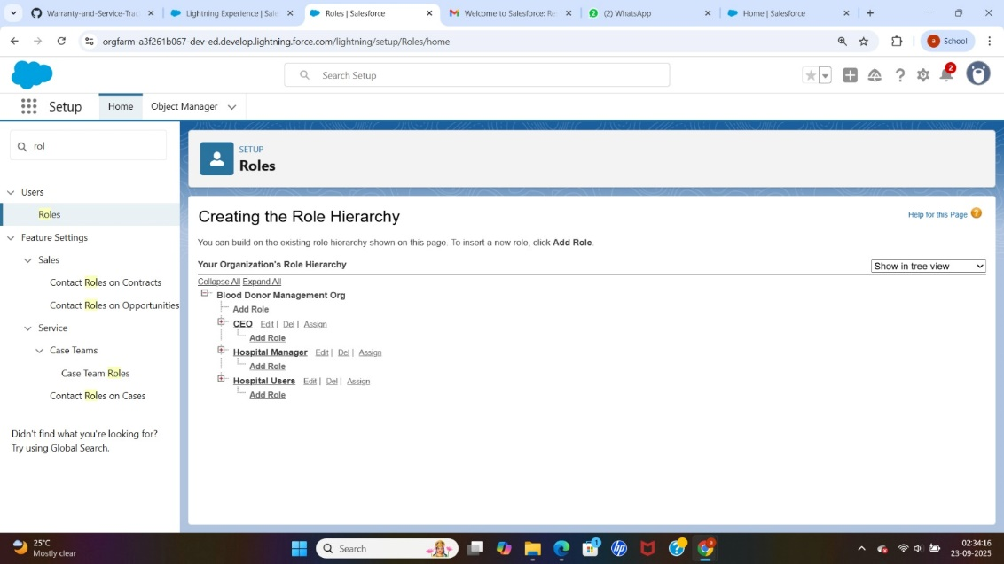

1. **Permission sets**

.Name: Event Access

. Object Settings: Donation_Event__c → Read/Write (enabled)

. Assign this permission set to Hospital User

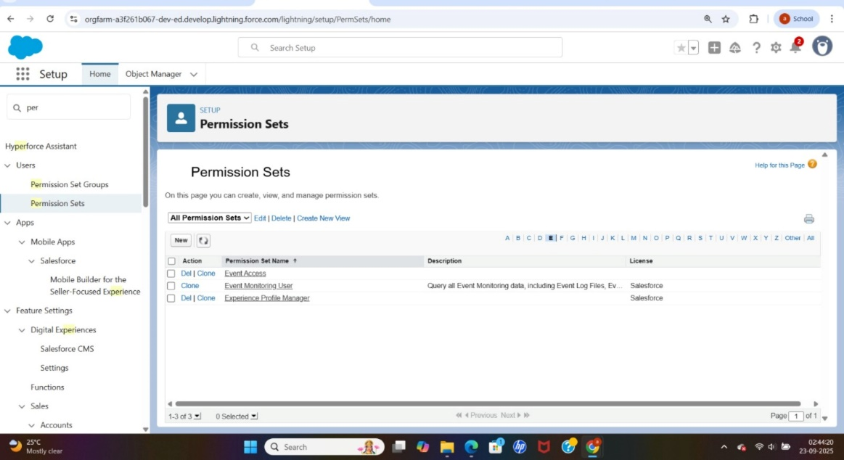

**9 OWD (Organization-Wide Defaults)**

1. Go to Setup → Sharing Settings.

2. Set object access:

Donor__c → Private

Donation_Request__c → Public Read-Only

Donation_Event__c → Public Read/Write

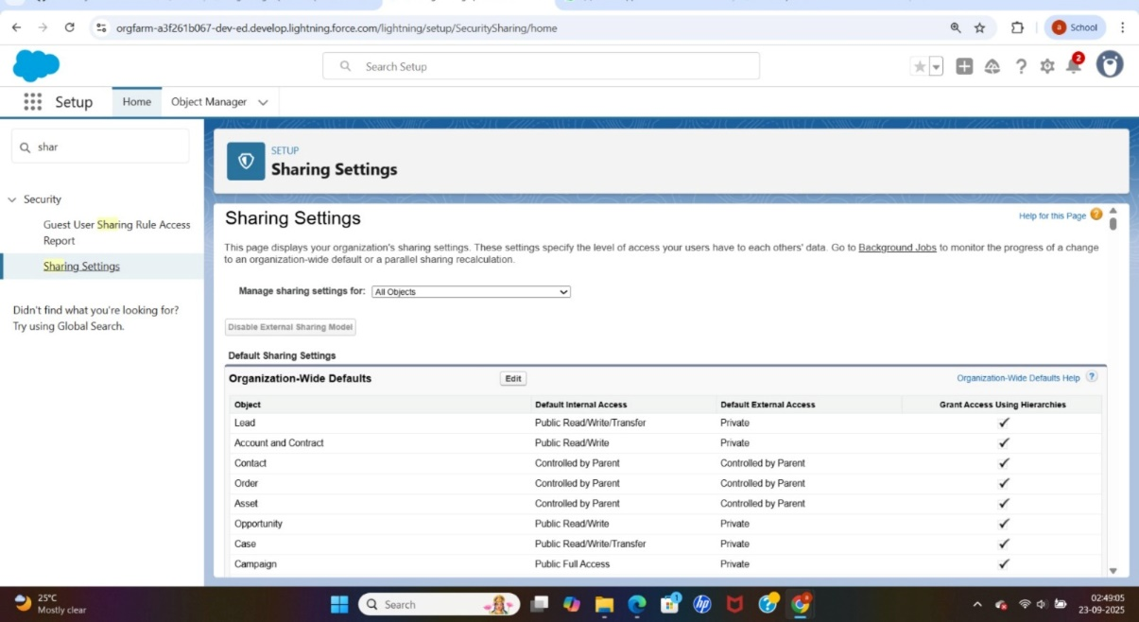

**10. Sharing Rules**

1. Go to Setup → Sharing Settings.

2. For Donor__c, create a new sharing rule:

Name: Share Donors with Hospital Manager

Rule Type: Based on Role

Share with: Hospital Manager

Access: Read Only

3. For Donation_Request__c, create a new sharing rule:

Share with: All Hospital Users

Access: Read/Write

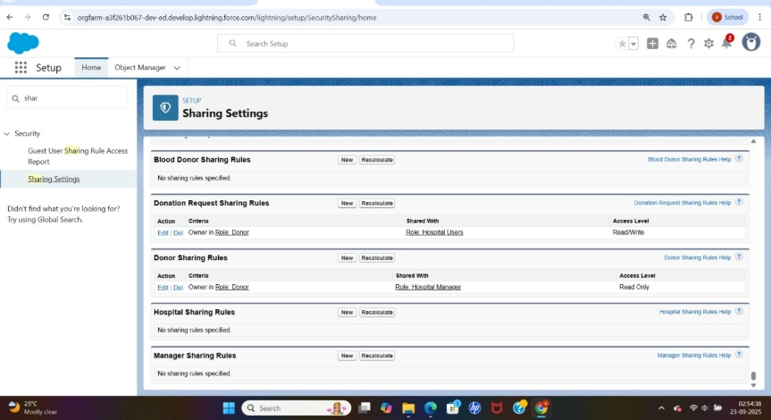

**11: Login Access Policies**

1. Setup Login Access Policies।

2. Enable: Administrators Can Log in as Any User

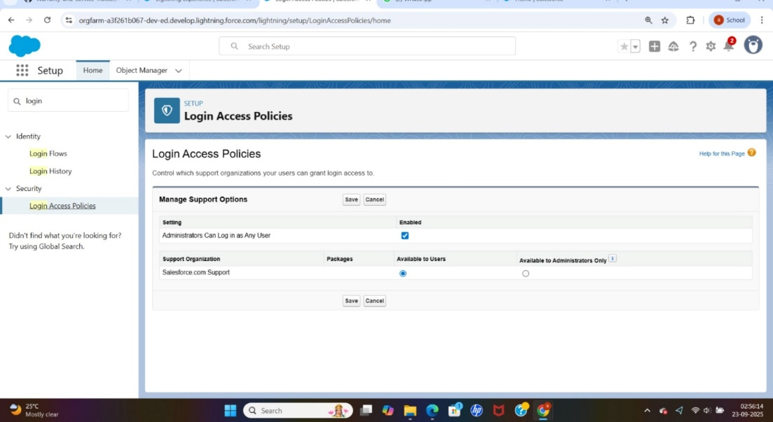

**12. Developer Org Setup**

Project developed in Salesforce Developer Edition Org.

Provides free Enterprise-level features suitable for learning and development purposes.

**13. Sandbox Usage**

Sandboxes are not available in Developer Edition.

In real-world companies, sandboxes are used for testing, development, and training without affecting Production.

**14. Deployment Basics**

Deployment methods include Change Sets or Salesforce CLI / VS Code.

Not required here since the project is fully developed and tested within a single Developer Org.